

AIRLINE SERVICES API DESCRIPTION

[Document subtitle]

Version 1.0

June 10, 2017

**Presented by: Germán Segura**

MUM – WAA CS545

1000 N 4st – FAIRFIELD IA

# this document presents the services of the webservice airlines web.

This document has the instructions to retrieve information for the services:

## AIRLINE

**{URL}: /airline**

| Methods | URI | Parameters | Response |
| --- | --- | --- | --- |
| **GET** | / |  | List<Airline> |
|  | /type/value | Type: String , Value String |
|  |  | Type: ID - Id of the airline |
|  |  | Type NAME - Name of the airline |
| **POST** | / | Airline | HTTP Status Code200 |
| **PUT** | / | Airline | HTTP Status Code200 |
| **DELETE** | / | Long id |  |

## AIRPLANE

**{URL}: /airplane**

| Methods | URI | Parameters | Response |
| --- | --- | --- | --- |
| **GET** | / |  | List<Airpline> |
|  | /type/value | Type: String  Value String  **Types:** |
|  |  | * MODEL - Model of the airplane |
|  |  | * SERIAL - Name of the airplane |
|  |  | * FLIGHT – Number of the airplane |
| **POST** | / | Airplane | HTTP Status Code200 |
| **PUT** | / | Airplane | HTTP Status Code200 |
| **DELETE** | / | Long id | HTTP Status Code200 |

## AIRPORT

| Methods | URI | Parameters | Response |
| --- | --- | --- | --- |
| **GET** | / |  | List<Airport> |
|  | /type/value | Type: String  Value String  **Types:** |
|  |  | * CITY - City of the airport |
|  |  | * COUNTRY - Country of the airport |
|  |  | * NAME – Name of the airport |
|  |  | * CODE – Code of the airport |
|  |  | * DEPARTURE – Number of the flight departure |
|  |  | * ARRIVAL – Number of the flight departure |
| **POST** | / | Airport | HTTP Status Code200 |
| **PUT** | / | Airport | HTTP Status Code200 |
| **DELETE** | / | Long id | HTTP Status Code200 |

## FLIGHT

| Methods | URI | Parameters | Response |
| --- | --- | --- | --- |
| **GET** | / |  | List<Flight> |
|  | /type/value | Type: String  Value String  **Types:** |
|  |  | * NUMBER - Number of the flight |
|  |  | * AIRLINE - Name of the airline |
|  |  | * ORIGIN – Code of the airport |
|  |  | * DESTINY – Code of the airport |
|  |  | * AIRPLANE – Model of airplane |
|  |  | * ARR_DATE – Date of arrival |
|  |  | * DEP_DATE: Date of departure |
|  | /type/datefrom/dateto | Type: String  Datefrom: MM-dd-yyyy HH:mm:ss  Dateto: MM-dd-yyyy HH:mm:ss  **Types:** |
|  |  | * ARR_DATES: Dates of arrival |
|  |  | * DEP_DATES: Dates of departure |  |
| **POST** | / | Flight | HTTP Status Code200 |
| **PUT** | / | Flight | HTTP Status Code200 |
| **DELETE** | / | Long id | HTTP Status Code200 |

## EXAMPLES OF CONSUMING SERVICES

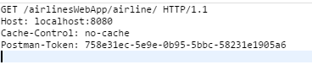

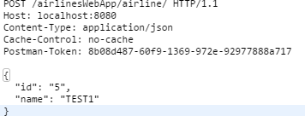

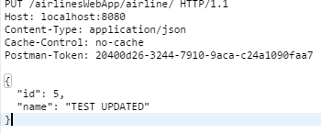

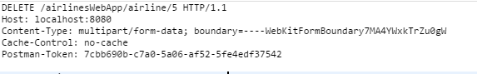

## postman link

[**https://documenter.getpostman.com/view/2049058/collection/6Z3uXeY**](https://documenter.getpostman.com/view/2049058/collection/6Z3uXeY)

